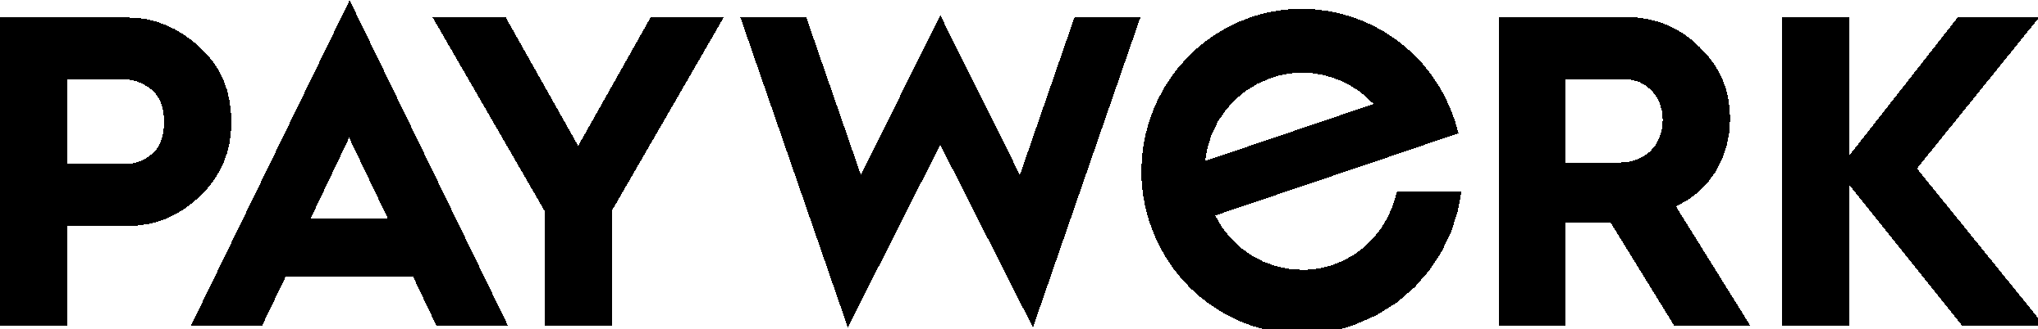 terms of use

These terms of use (“Terms“) apply between you (“you“, “your“) and Paywerk AS, a licensed payment institution (“we“, “us”, “our” or “Paywerk”), when you use our web site located at paywerk.co, including any related domain or subdomain („Website“). We reserve the right to amend the Terms at any time and post the updated Terms on the Website. You acknowledge that each time you use the Website, you agree to the then current version of these Terms and enter into an agreement with Paywerk, which amends any earlier agreements with us.
USE OF THE WEBSITE
You can simply view the Website and you do not need to register an account with Paywerk to use the Website. You can also register a user account in the Shopper Portal, subject to terms.
In case you visit the Website or submit any information to Paywerk via the Website, we process your personal data (your IP-address, device data, session data etc). For more information on how we use this data, please review Paywerk’s Privacy Notice, available on the Website.
By using the Website, you represent and warrant (i) you are at least 18 years of age, (ii) you are using the Website at your own risk, (iii) you are using the Website in compliance with applicable law and (iv) you are responsible for using a device with secure and up-to-date software to access the Website (e.g. a secure internet connection, using an updated operating system, web browser and security software).
Paywerk reserves the right to suspend your access to and any further use of the Website and/or other Paywerk services in case of fraud, breach of these Terms or misuse of the Website.
CONTENT
We take reasonable care to ensure any content (information, software, design, logos, images – together the “Content“) on the Website is accurate when posted and regularly updated. However, Paywerk does not guarantee the accuracy of the Content and is not liable for any damages from the usage of the Website or the Content to the extent allowed under applicable law.
The Website and the Content are the sole and exclusive property of Paywerk or, where indicated, our third-party licensors. Reproduction, distribution, modification, retransmission, or publication of the Website or the Content for non-personal use, to the extent allowed under applicable law, is strictly prohibited without a respective license or express written consent from Paywerk or the respective licensor.
We may publish links to third-party websites (i.e. not controlled by Paywerk) on our Website for your convenience and enhanced user experience. You acknowledge Paywerk provides third-party websites and/or content as supplied to us and is not responsible for any third-party websites, their content or any products or services offered therein. You agree to visit any third-party website at your own risk and comply with the respective terms and conditions.
LIABILITY
Paywerk provides the Website „as is“ without any warranties of any kind, express or implied, as to the operation and availability of the Website and accuracy of the Content. Paywerk shall not be liable for any damages resulting from your access to or use of the Website or the Content to the fullest extent allowed under applicable law. In no event shall Paywerk be liable for any indirect or consequential damages.
APPLICABLE LAW
The Terms are governed by the laws of the Republic of Estonia and Estonian courts shall have exclusive jurisdiction in any dispute related to these Terms or the Website.

